SS three-phase AC motor drives
User's Manual
This drive is suitable for single-phase 220V AC input, 25 ~ 200W three-phase motor speed regulation.
This manual is provided installation and debugging and routine maintenance to the user.
Please read it before used and safekeeping.

Use of the environment:
Power: Single phase AC220V ± 10% of
Temperature: -10 °C ~ 50 °C
Humidity: 0% to 65%
Precautions
When wiring, be sure to turn off the power.
The wiring sure never to the AC power supply to the motor output.
Use the site without condensation, dust, non-corrosive liquid, gas.
Install parts rugged, vibration-free.
Should be smaller overall, wiring thread.
When the ambient temperature is too high, leaving enough space for heat dissipation.

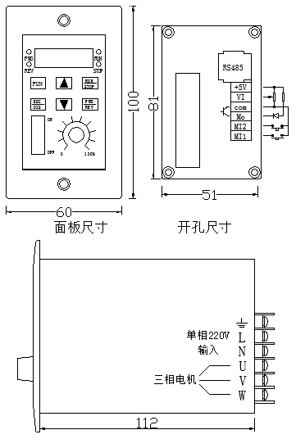
AC220
MOTOR
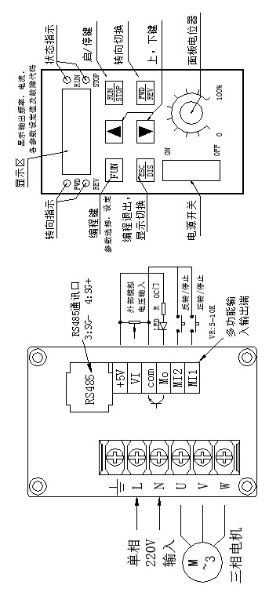
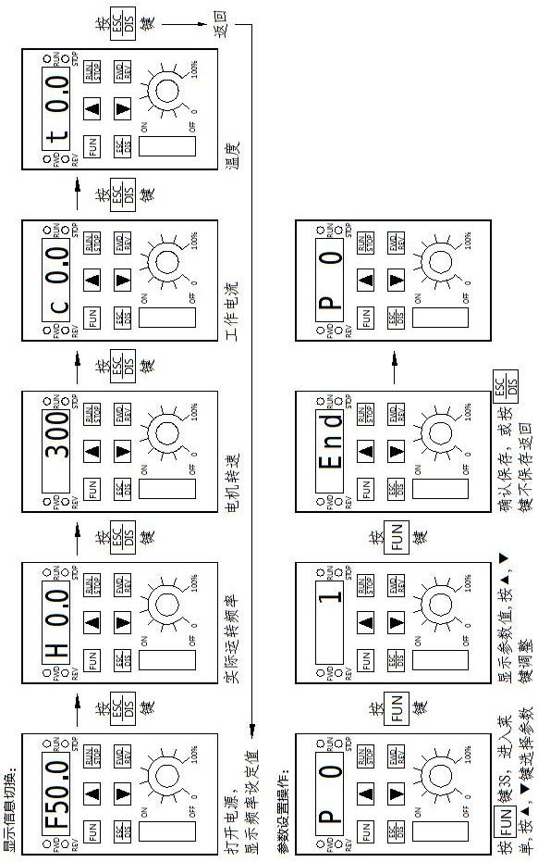

Parameter list：
parameter | Parameter specification | Parameter rang | default
P00 | Working frequency | 0～400Hz | 50Hz
P01 | Working frequency source | 0:Panel keyboard  1:panel potentiometer  2:external potentiometer  3:RS485 | 1
P02 | Run/stop  control source | 0:Panel keyboard  1:RS485  2: forward directly After power on  3:reversal directly After power on  4:external port | 0
P03 | Stop way | 0: Inertia stop  1:slow stop  2:braking stop | 1
P04 | Maximum operating frequency | 0～400Hz | 65Hz
P05 | Lowest operating  frequency | 0～400Hz | 5HZ
P06 | Increase speed of  Frequency | 0.1～500HZ/S | 25HZ/S
P07 | Decline speed of  Frequency | 0.1～500HZ/S | 25HZ/S
P08 | Braking time | 0-2.5S | 0.3S
P09 | Braking coefficient | 0～60％ | 20％
P10 | 3Hz VF value | 0～40％ | 10％
P11 | 50Hz VF value | 0～100％ | 98％
P12 | RS485 format | 0，7n2 ASCII  1，7e1 ASCII  2，7o1 ASCII  3，8n2 ASCII  4，8e1 ASCII  5 , 8o1 ASCII  6 , 8n2 RTU  7 , 8e1 RTU  8 , 8o1 RTU  9 , 8n1 RTU | 3
P13 | RS485 Baud rate | 0, 4.8K  1，9.6K  2，19.2K  3，38.4K | 1
P14 | Machine number | 1～255 | 1
P15 | MI Function Selection | 0:MI1:forward/Stop,  MI2:Reverse/Stop；  1 :MI1:Run/Stop，  MI2:Reverse/Forward；  2:MI1:Run/Stop | 0
P16 | MO Function Selection | 0 , 0:Stop；1：Run  1: 0：﹤Reach the frequency point  1：﹥= Reach the frequency point  2， 0：working normal  1：Driver board failure | 0
P17 | multi-speed | 0～400Hz | 50
P18 | Running to frequency | 0～400Hz | 50
P19 | Current Limiting | 1.0～4.0A | 2.5
P20 | Temperature limitation | 1℃～85℃ | 70℃
P21 | Drive ratio | 0.1～100 | 1
P22 | Carrier frequency | 8～15KHz | 8
P23 | Reverse forbidden | 0 , Reverse allows  1 ，Reverse forbidden | 0

Parameter Description：
FUN key is function keys ,with keyboard lock, Enter the function set after press it 3S.
RUN / STOP key is start and stop keys, press once to start, meanwhile RUN lamp lights, press it again to stop, STOP lamp lights. FWD / REV is switch key for turn to the direction of the motor, it will be change the direction when press once. FWD lamp lights when forward, REV lamp lights when reversal.
DIS key is display switch key, It will change among” actual working frequency →rotate speed of inverter →working current →temperature of inverter →set the frequency” when you press it each time.
Press FUN key to enter the function set, display P_0 ,then press↑ or ↓ keys to select P0 ~ 23 function items, Press FUN keys to enter. it will show xx ,and Press ↑ or ↓ keys to adjust the setting parameters, then press the FUN key save and exit, or press the ESC key to exit without saving.
P06, P07 parameters for acceleration and deceleration When start and stop, Example: P00 = 50Hz, P06 = 10Hz P07 = 25Hz, The motor reaches 50Hz after star 5S; Then motor down from 50Hz 0 after 2S when press stop.
P12 is 485 communication format selection. you have no need of set if only receive; Please set it when the signal format need returning.
P21 speed ratio, It can be show approximate speed on the basis of the pole of motor and reduction ratio:
2 pole motor 2800 ÷ 50Hz ÷ reduction ratio.
4 pole motor 1450 ÷ 50Hz ÷ reduction ratio
P19 overload set, please set P10, P11, and self-learning motor with good normal work load, follow these steps: Hold down the DIS key and then press the RUN / STOP button to enter the self-learning, press RUN / STOP key to start the self-learning, motor run automatically quit after learning from 10Hz ~ 50Hz. Set according to the motor conditions suitable overload percentage.
If you want to use this feature, please re-learning the P10, P11 parameters adjusted and motor load replacement.
Fault code:
EC: overload ;
ET: over temperature
E1: module protection
LV: low volt
OV: over volt
Reset the parameters:
If the parameter adjustment disorder, and can not be recover .Please turn off the power ,meanwhile holding down the FUN key, and then turn on the power, all the parameters will be recover to the factory defaults after show the DEF.

